Ανάλυση δεδομένων 10032020

# toluene 1 Z-scans

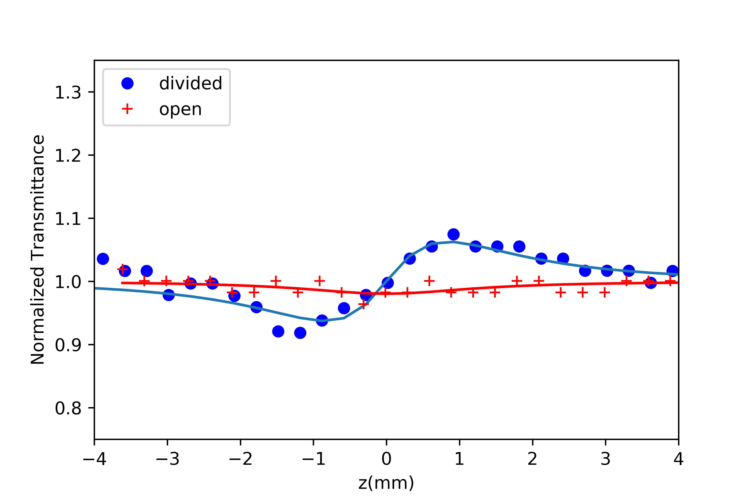

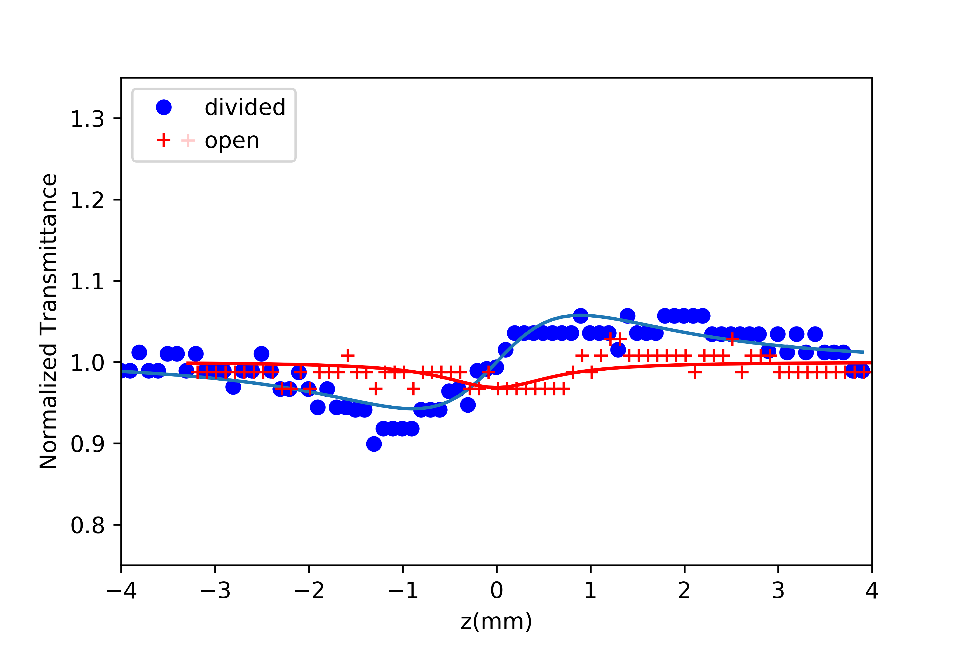

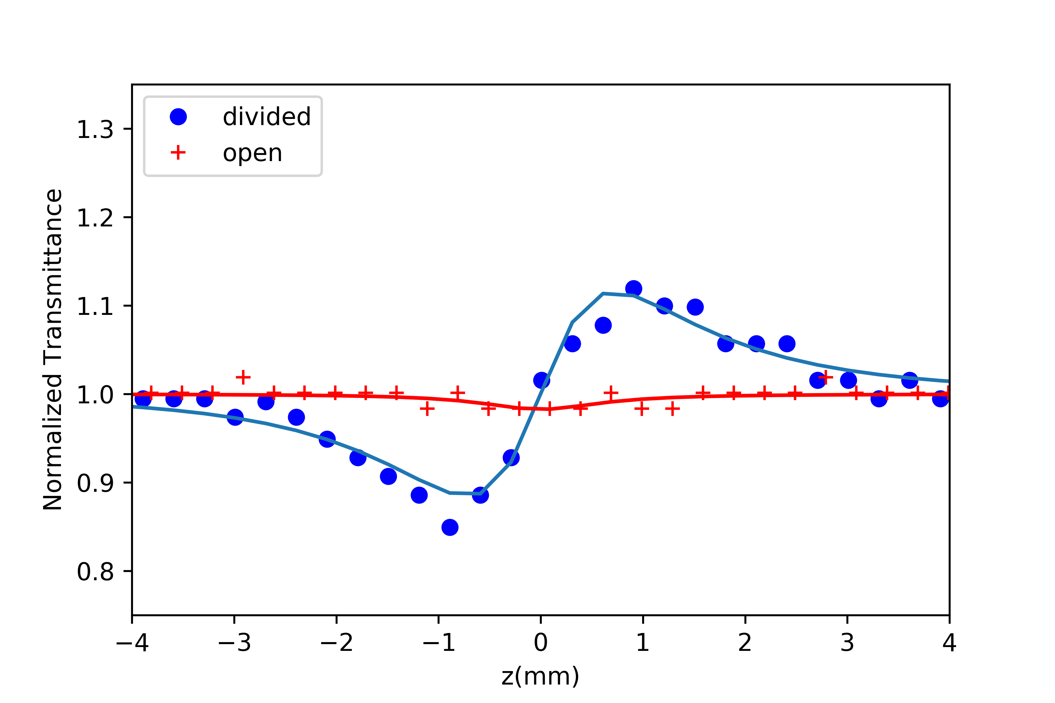

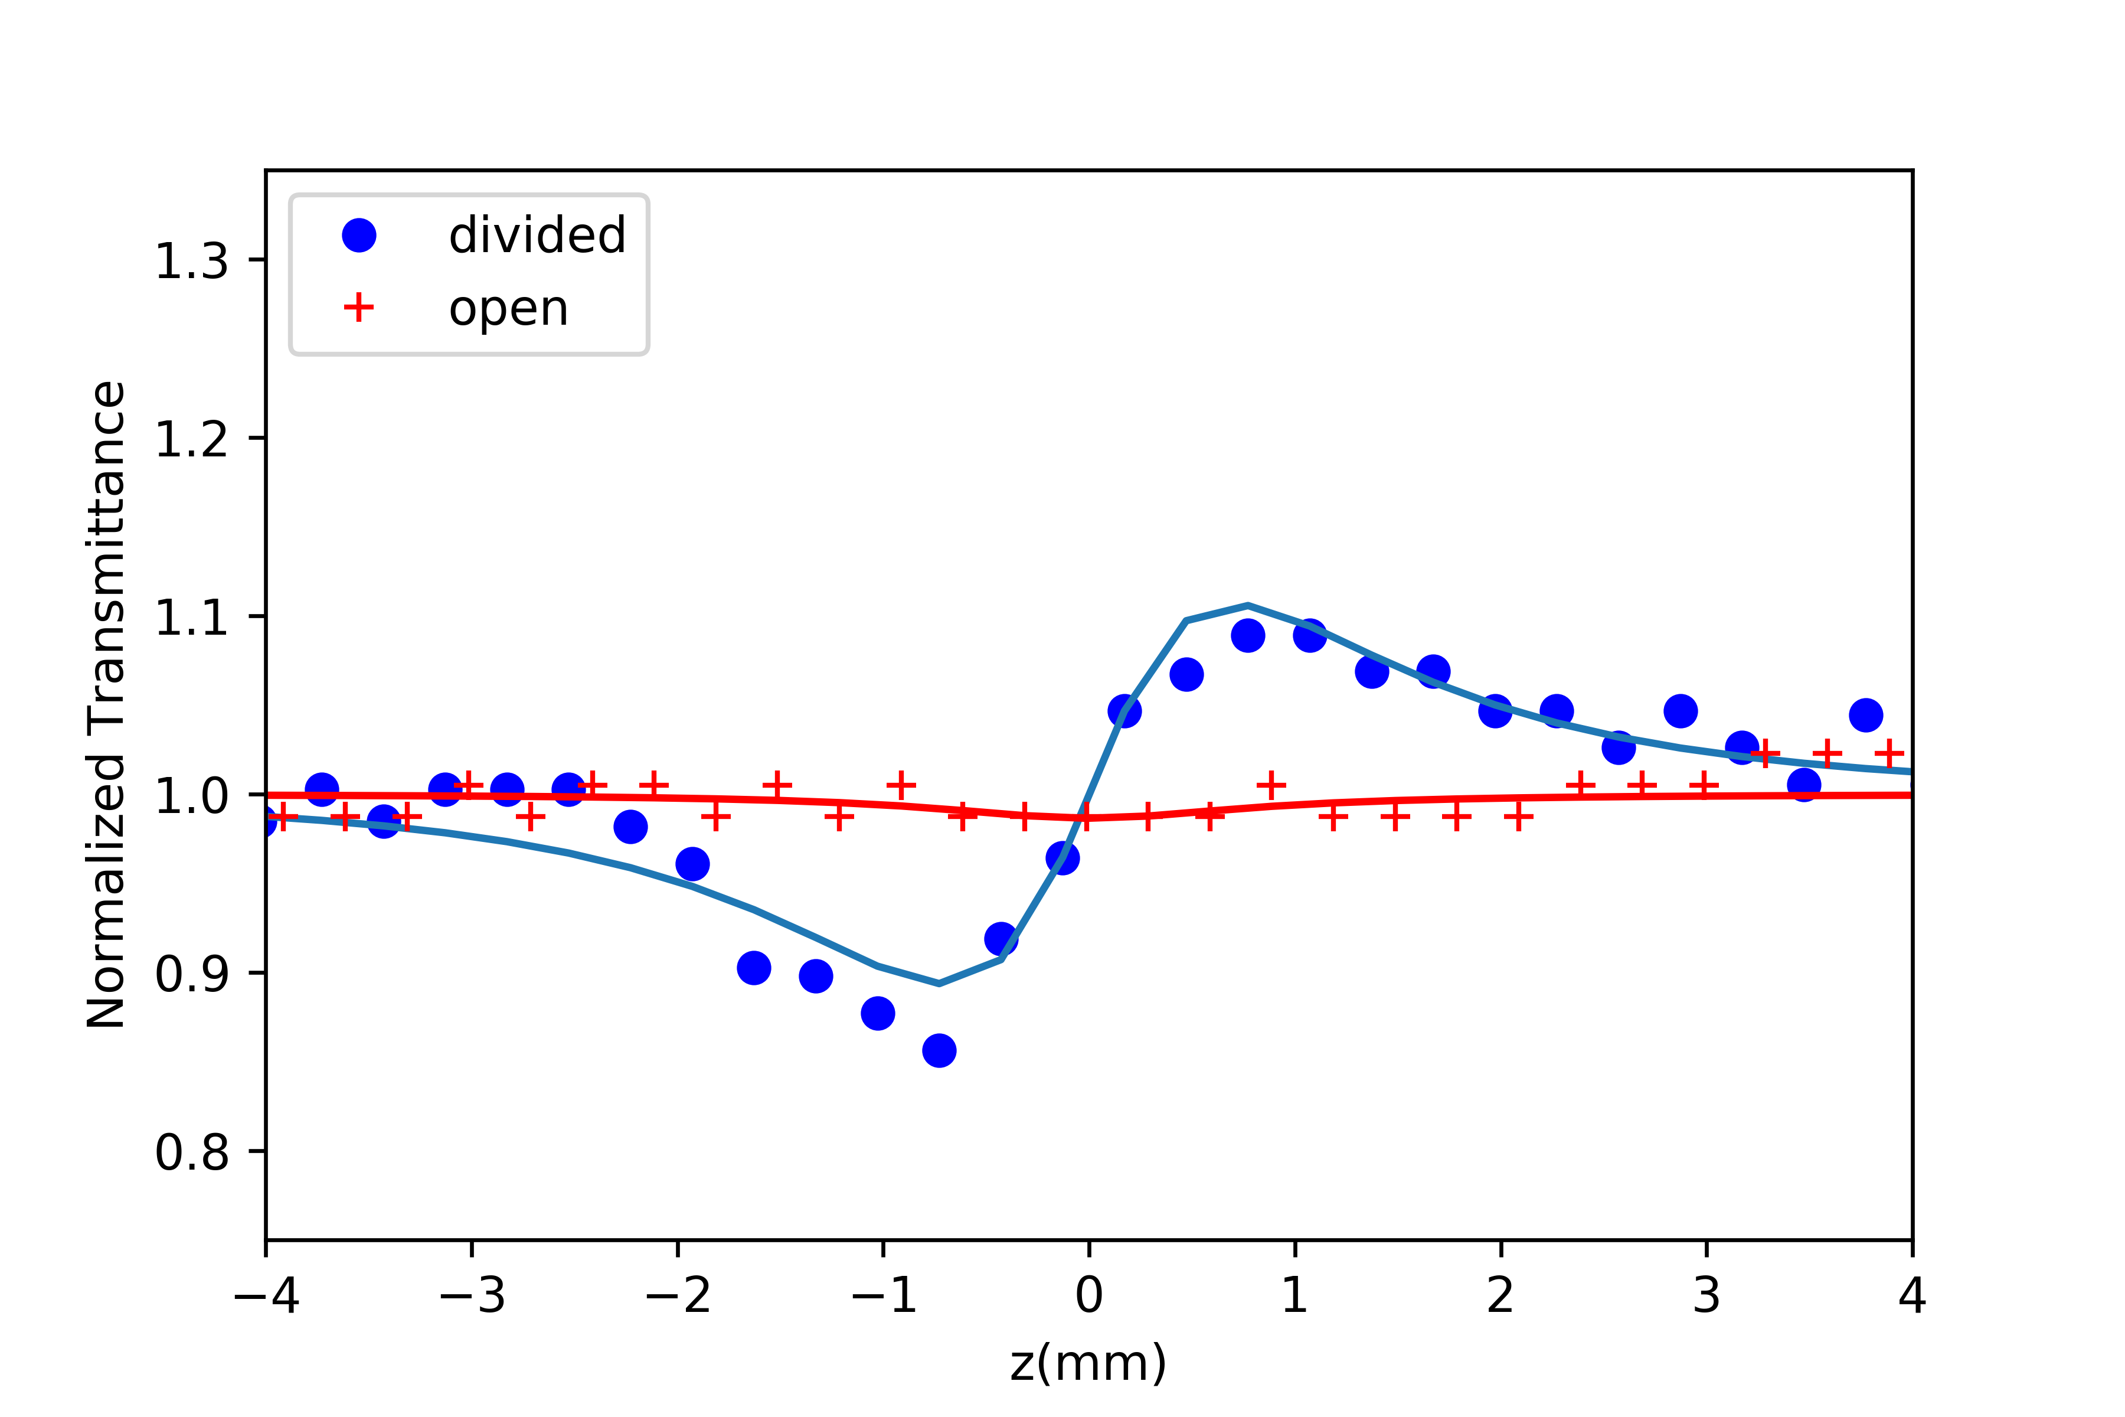

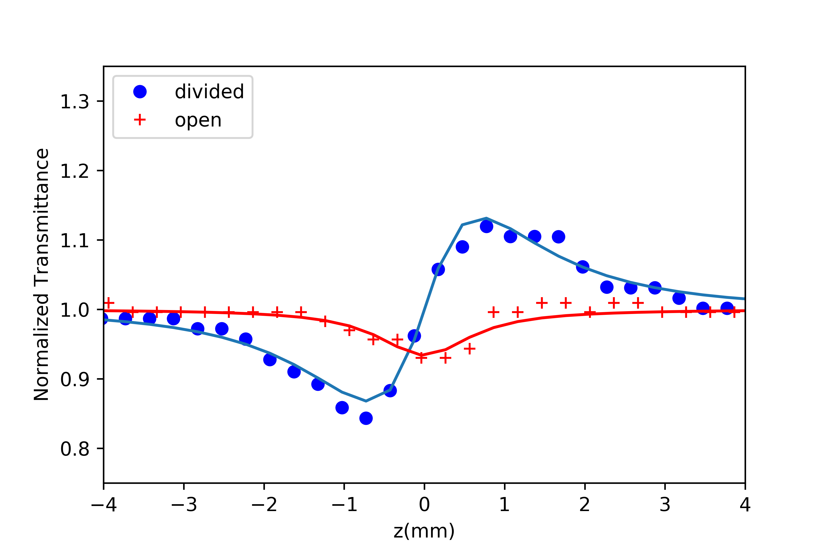

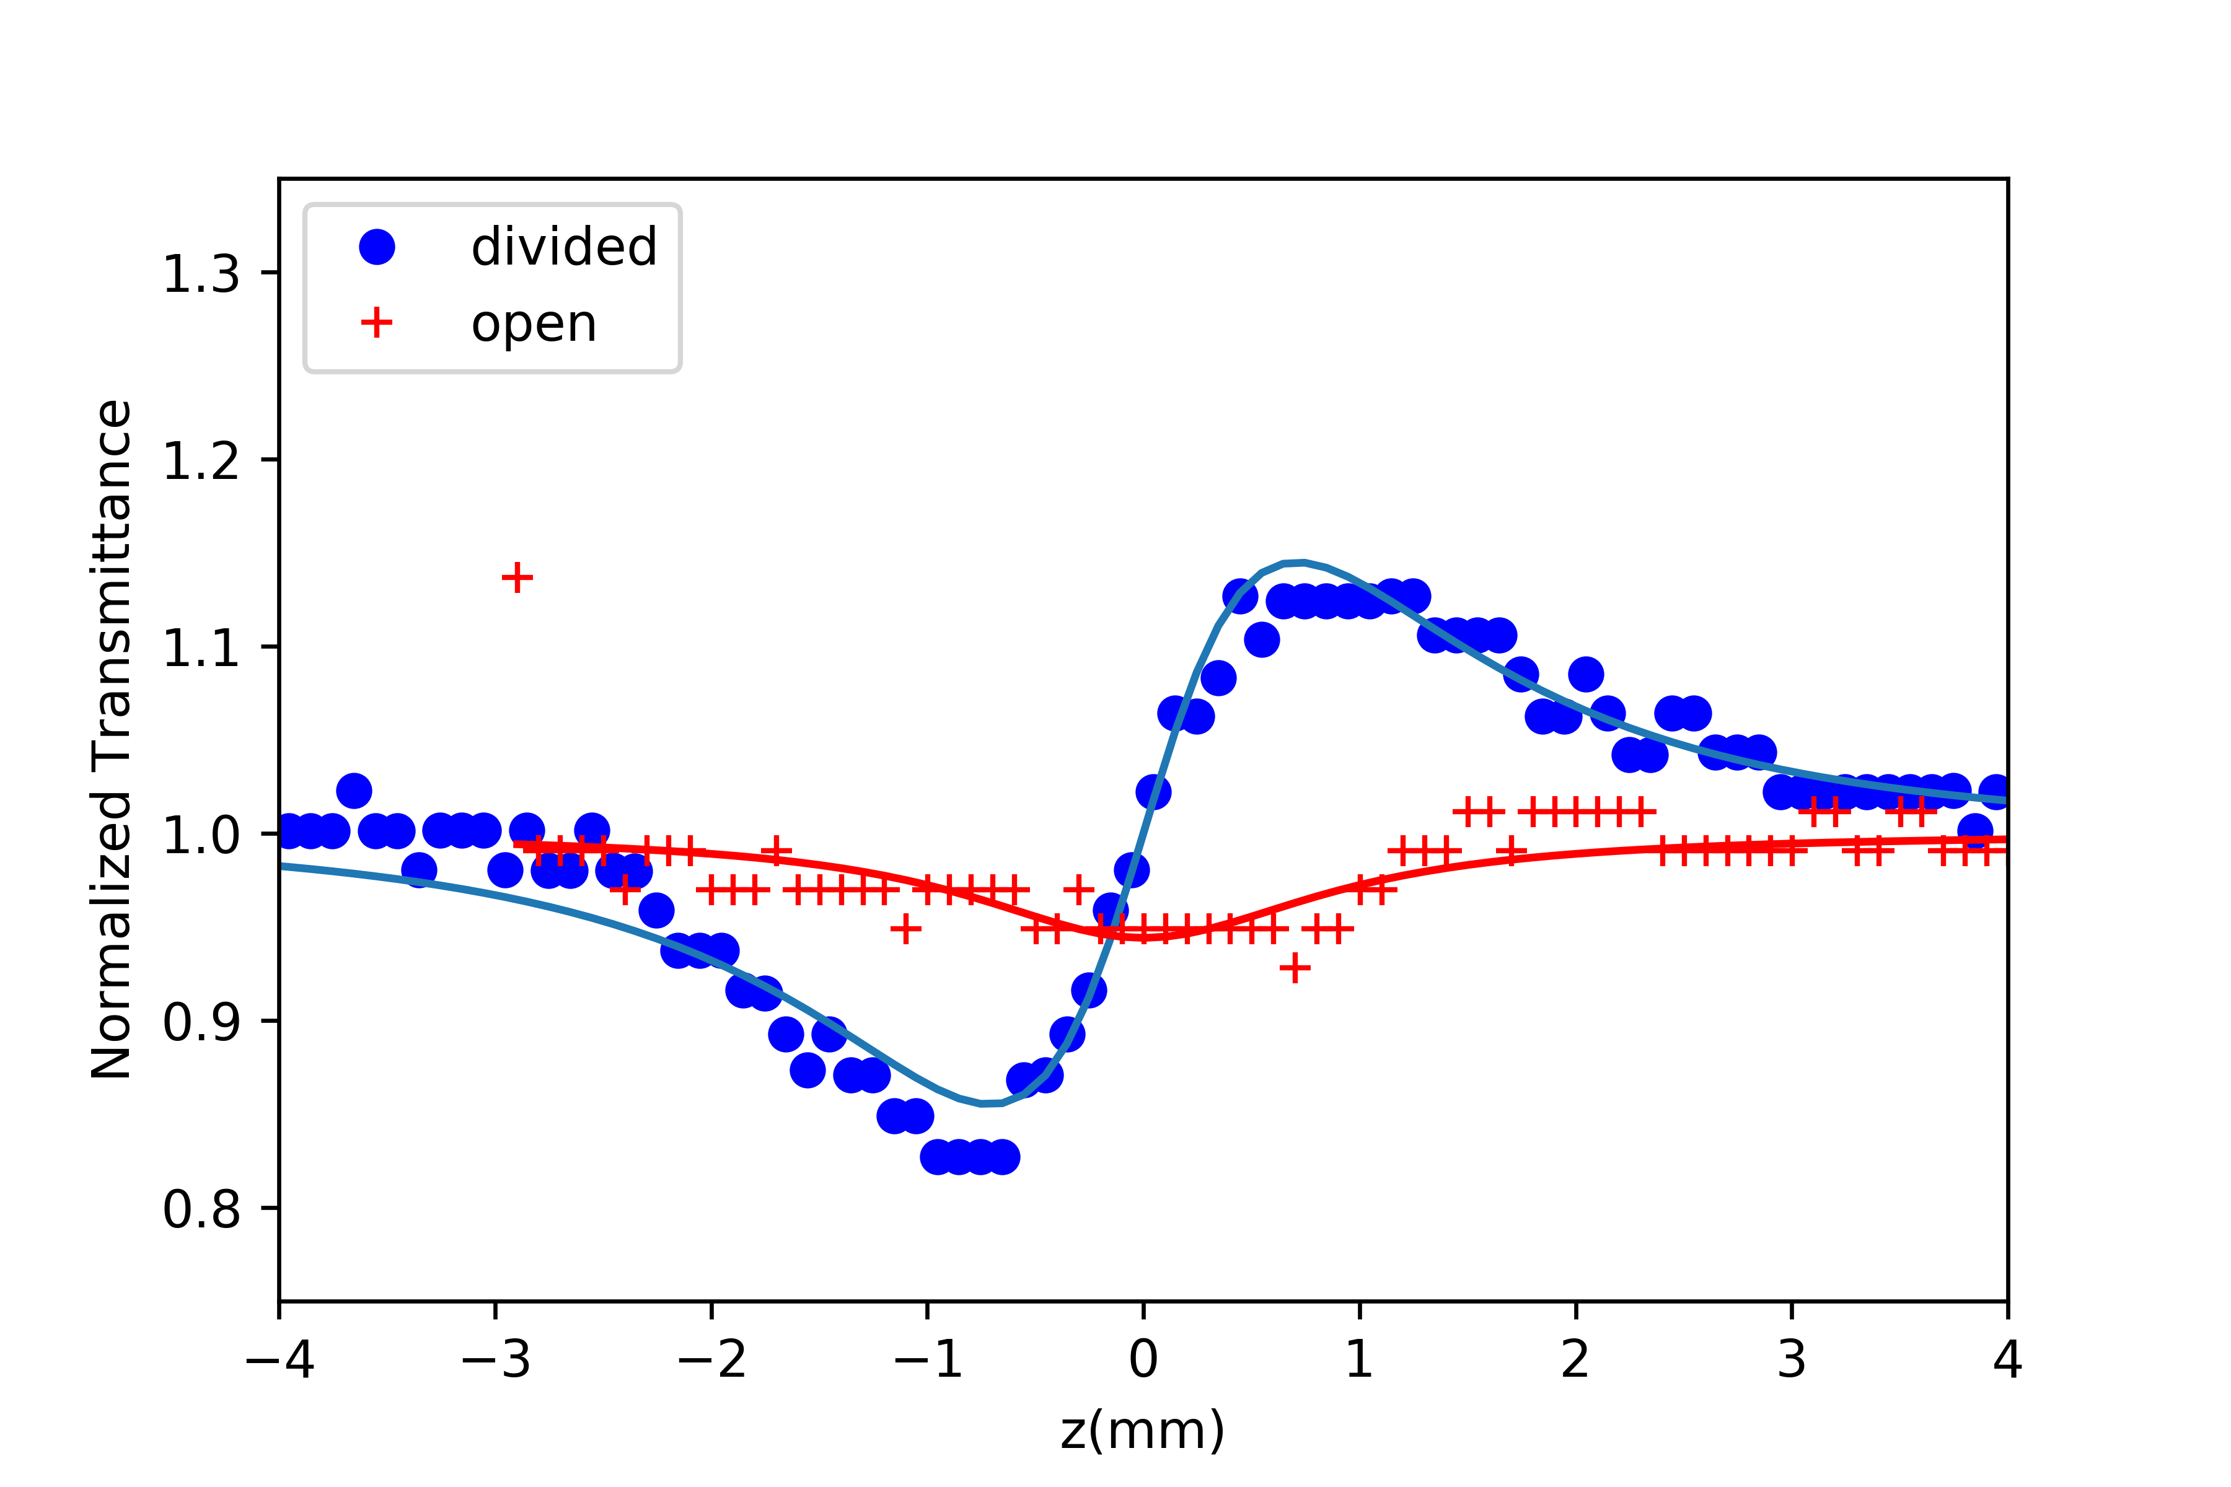

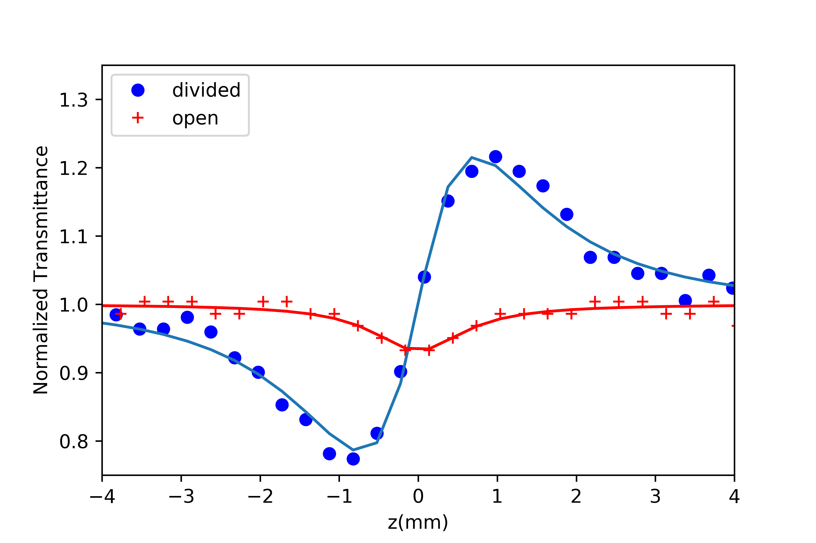

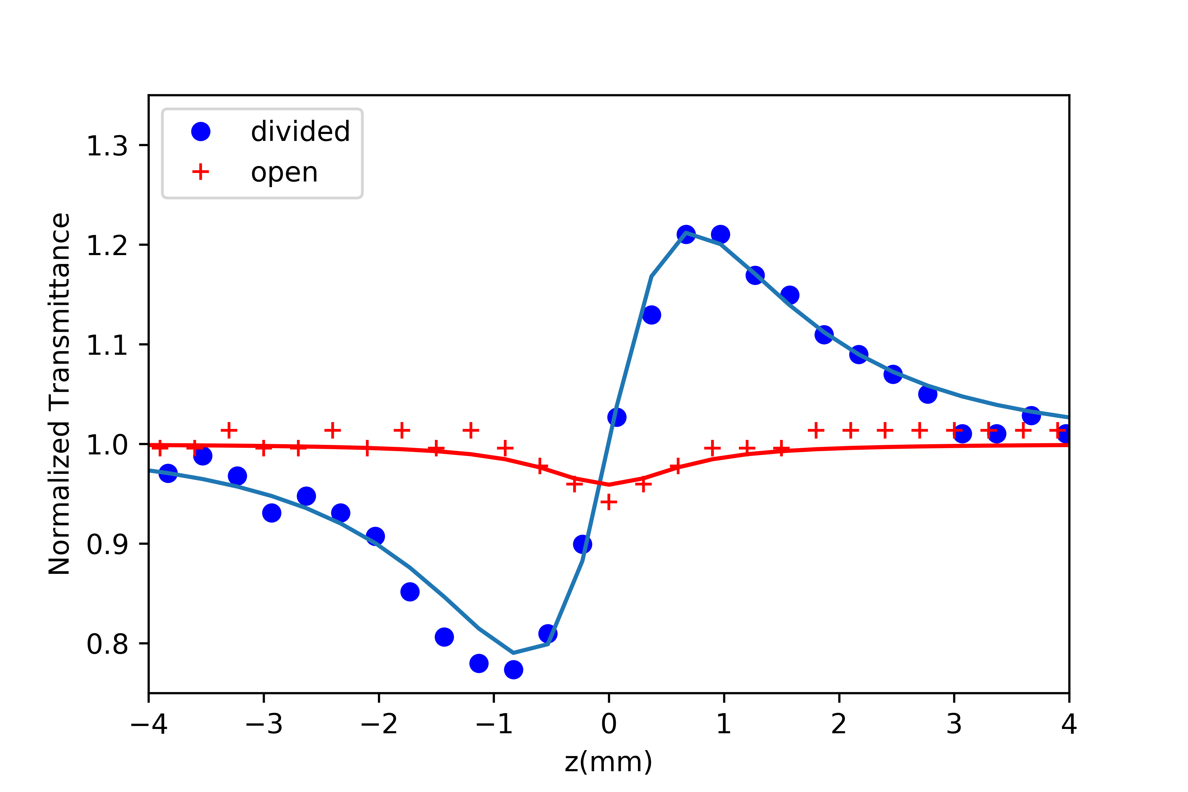

# toluene 1 ΔΤp-v

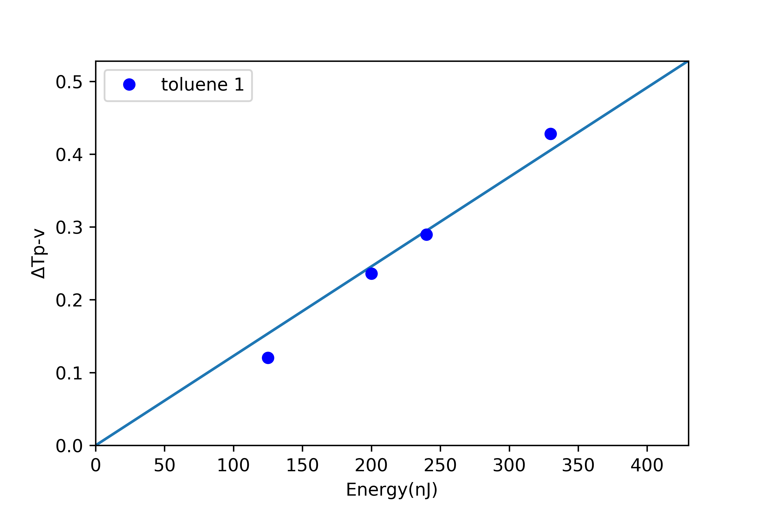

# 10 0.1 mM Z-scans

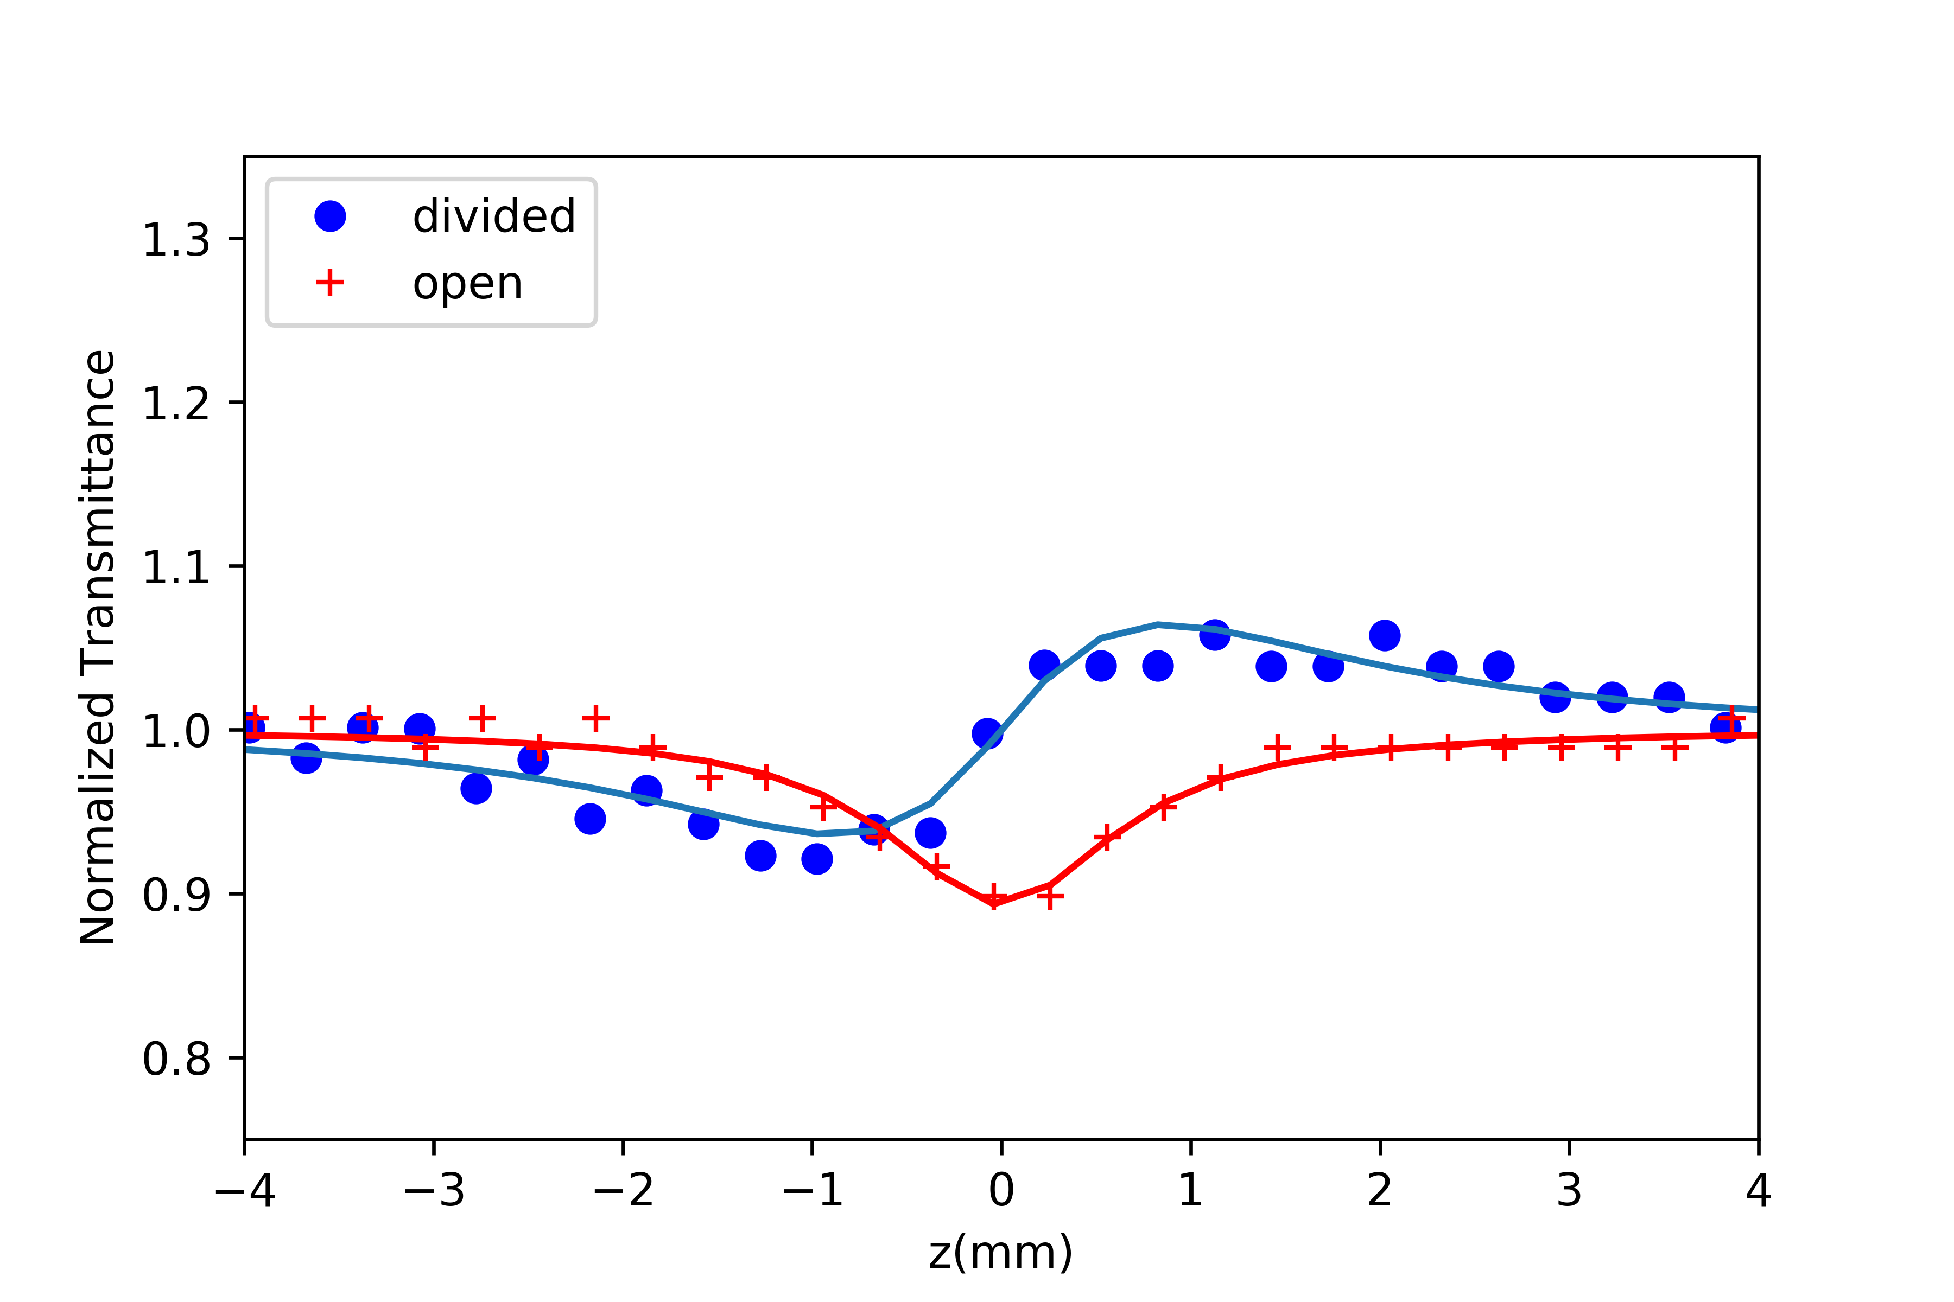

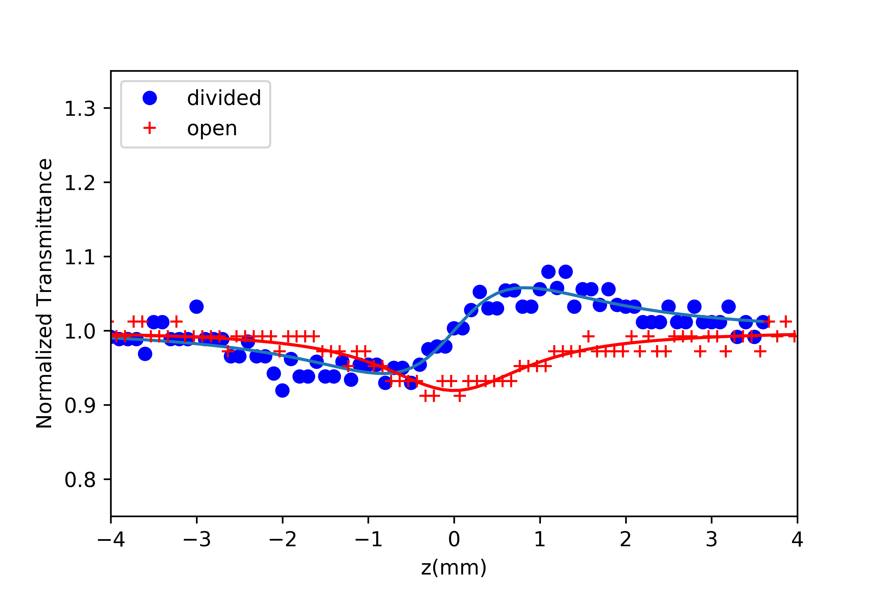

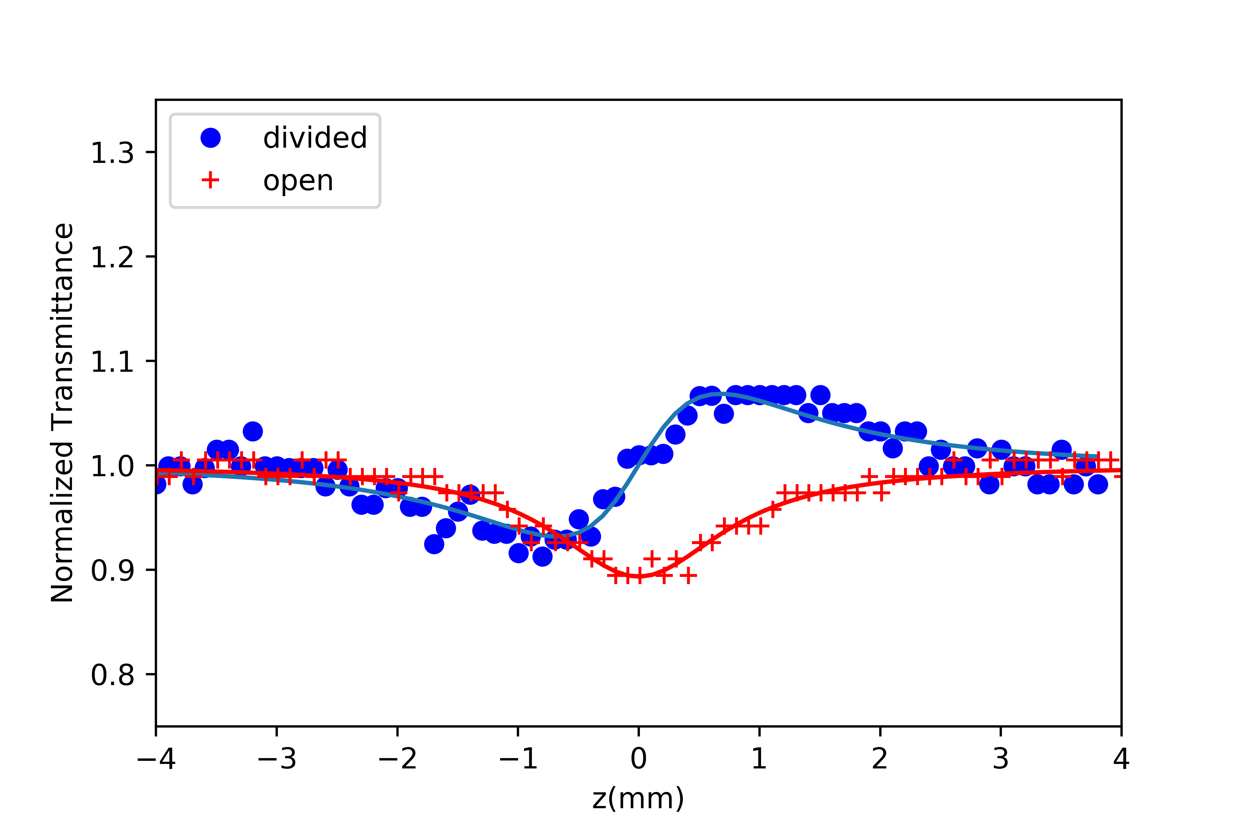

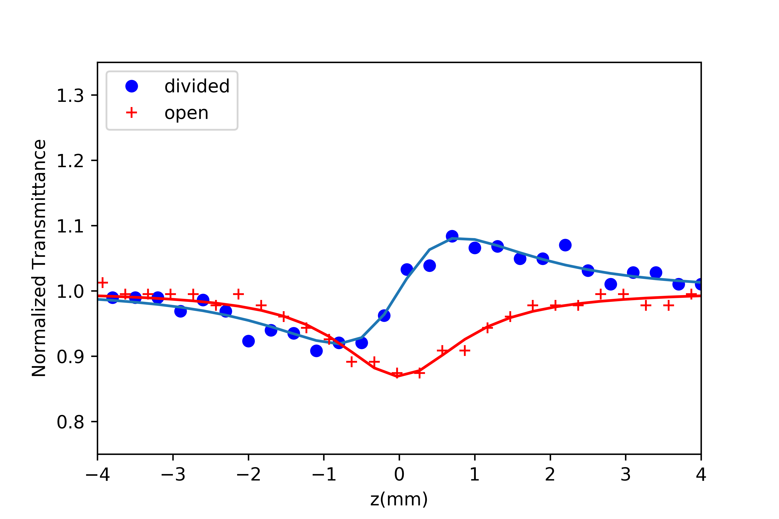

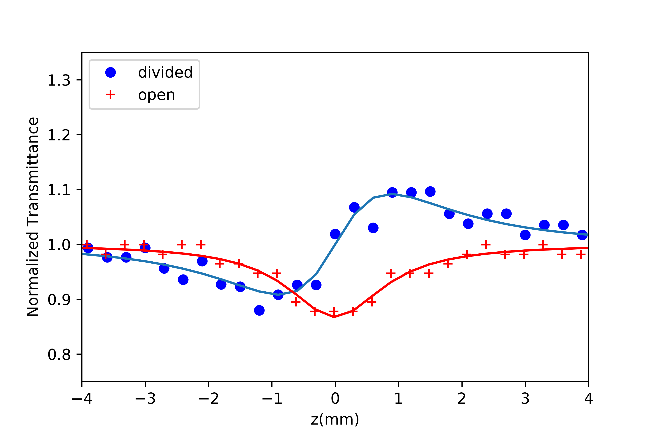

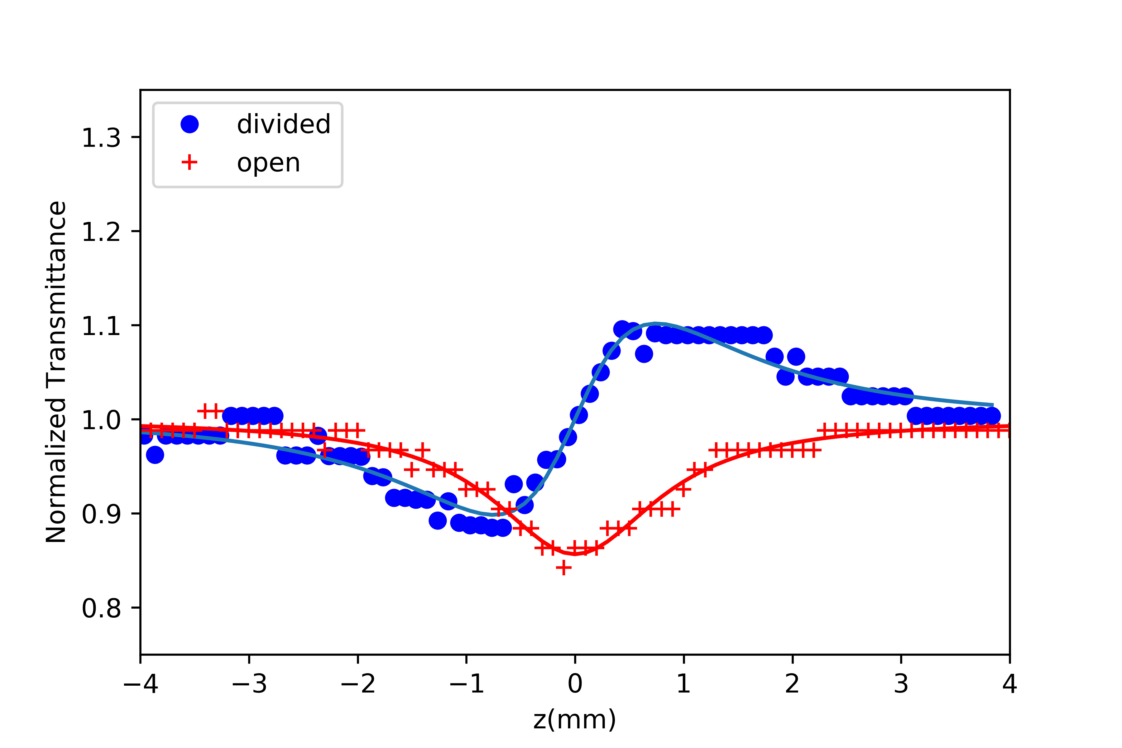

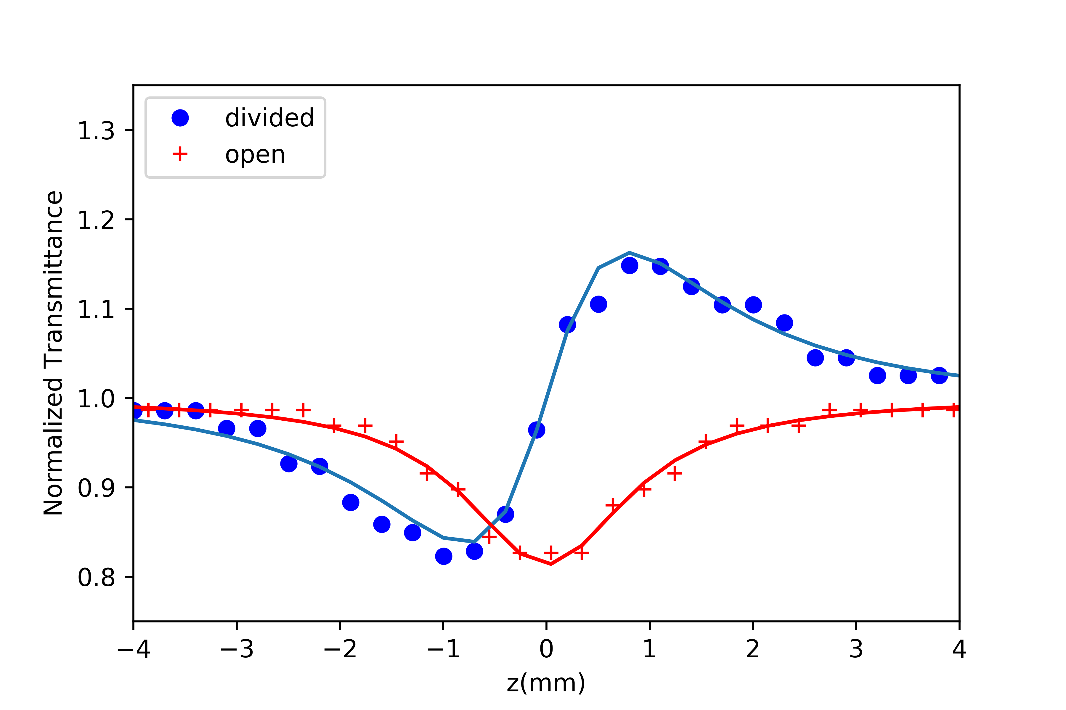

# 10 0.1 mM ΔΤp-v

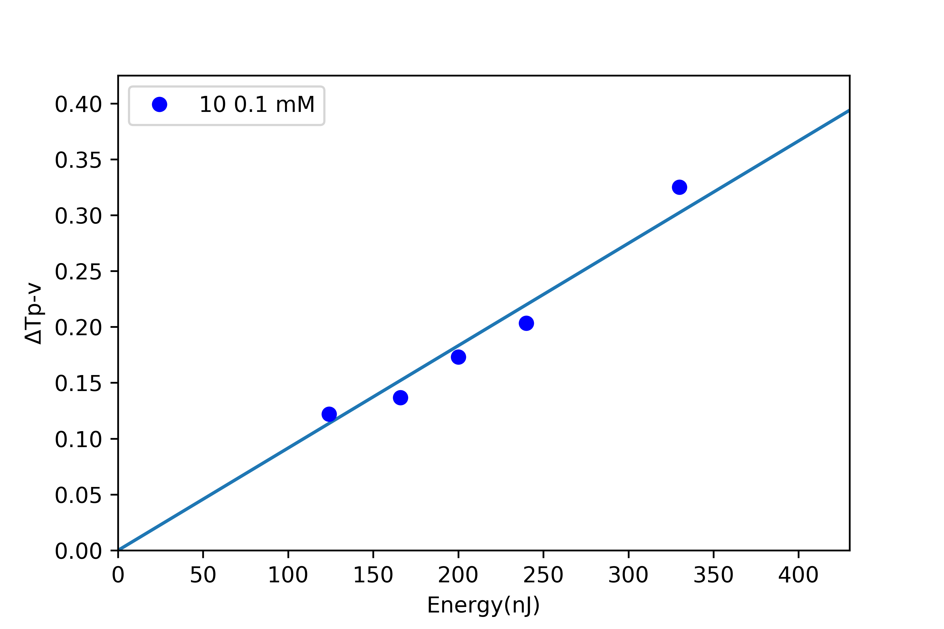

# 10 0.21 mM Z-scans

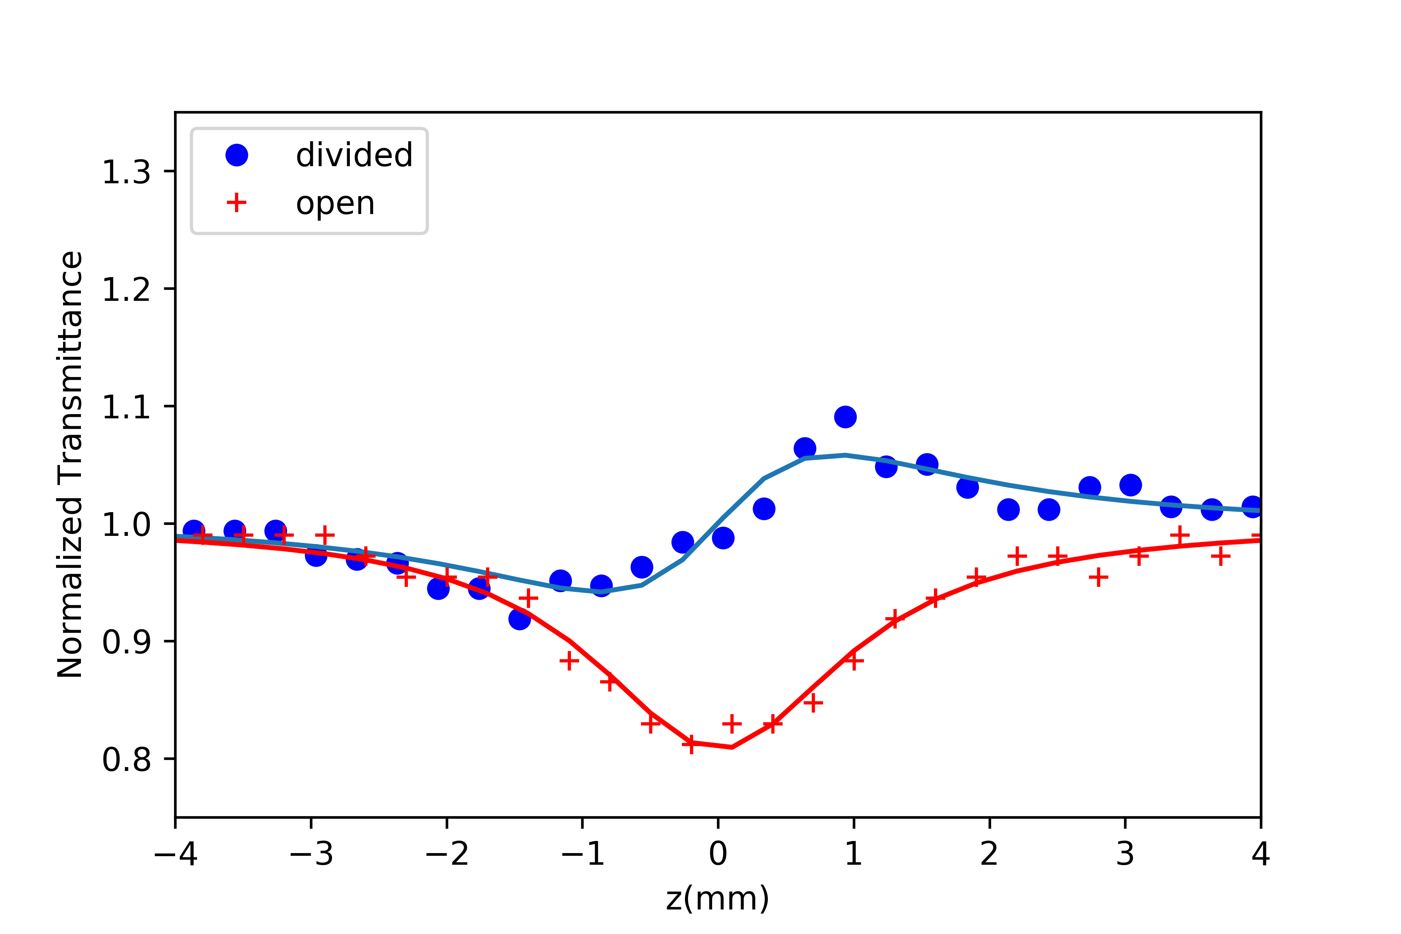

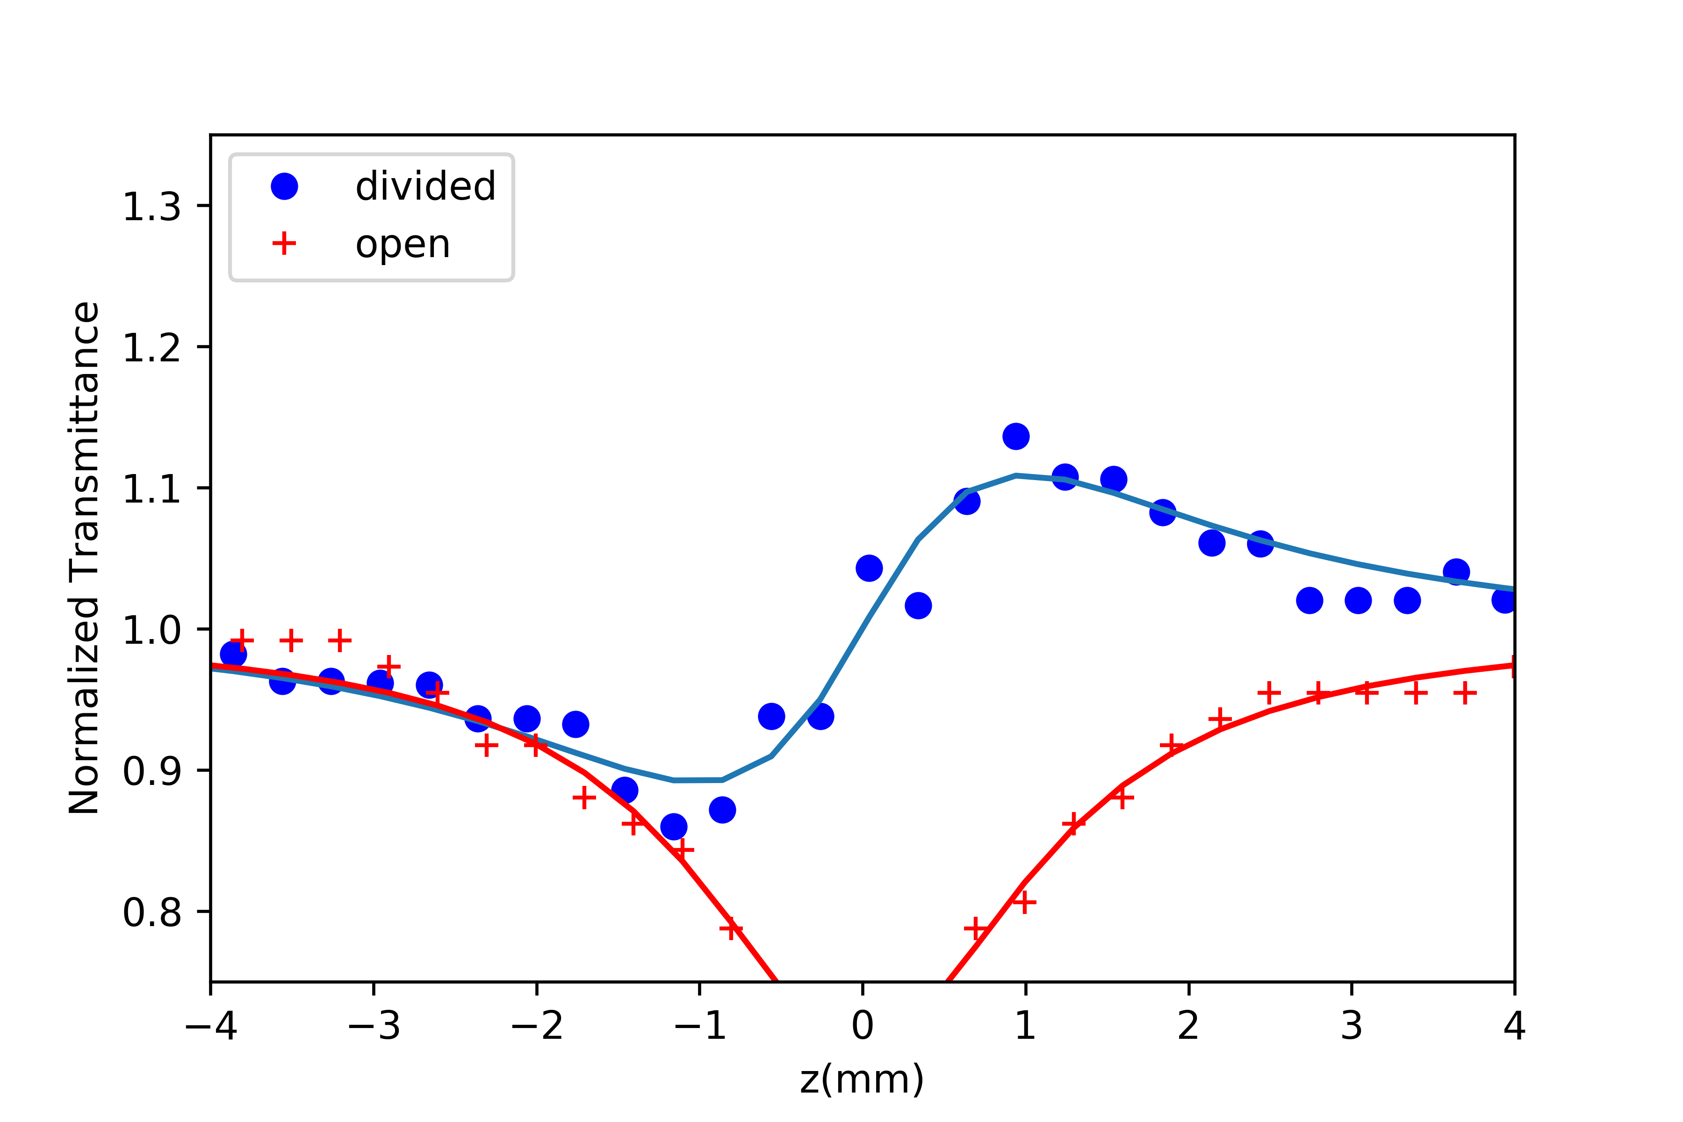

# 10 0.21 mM ΔΤp-v

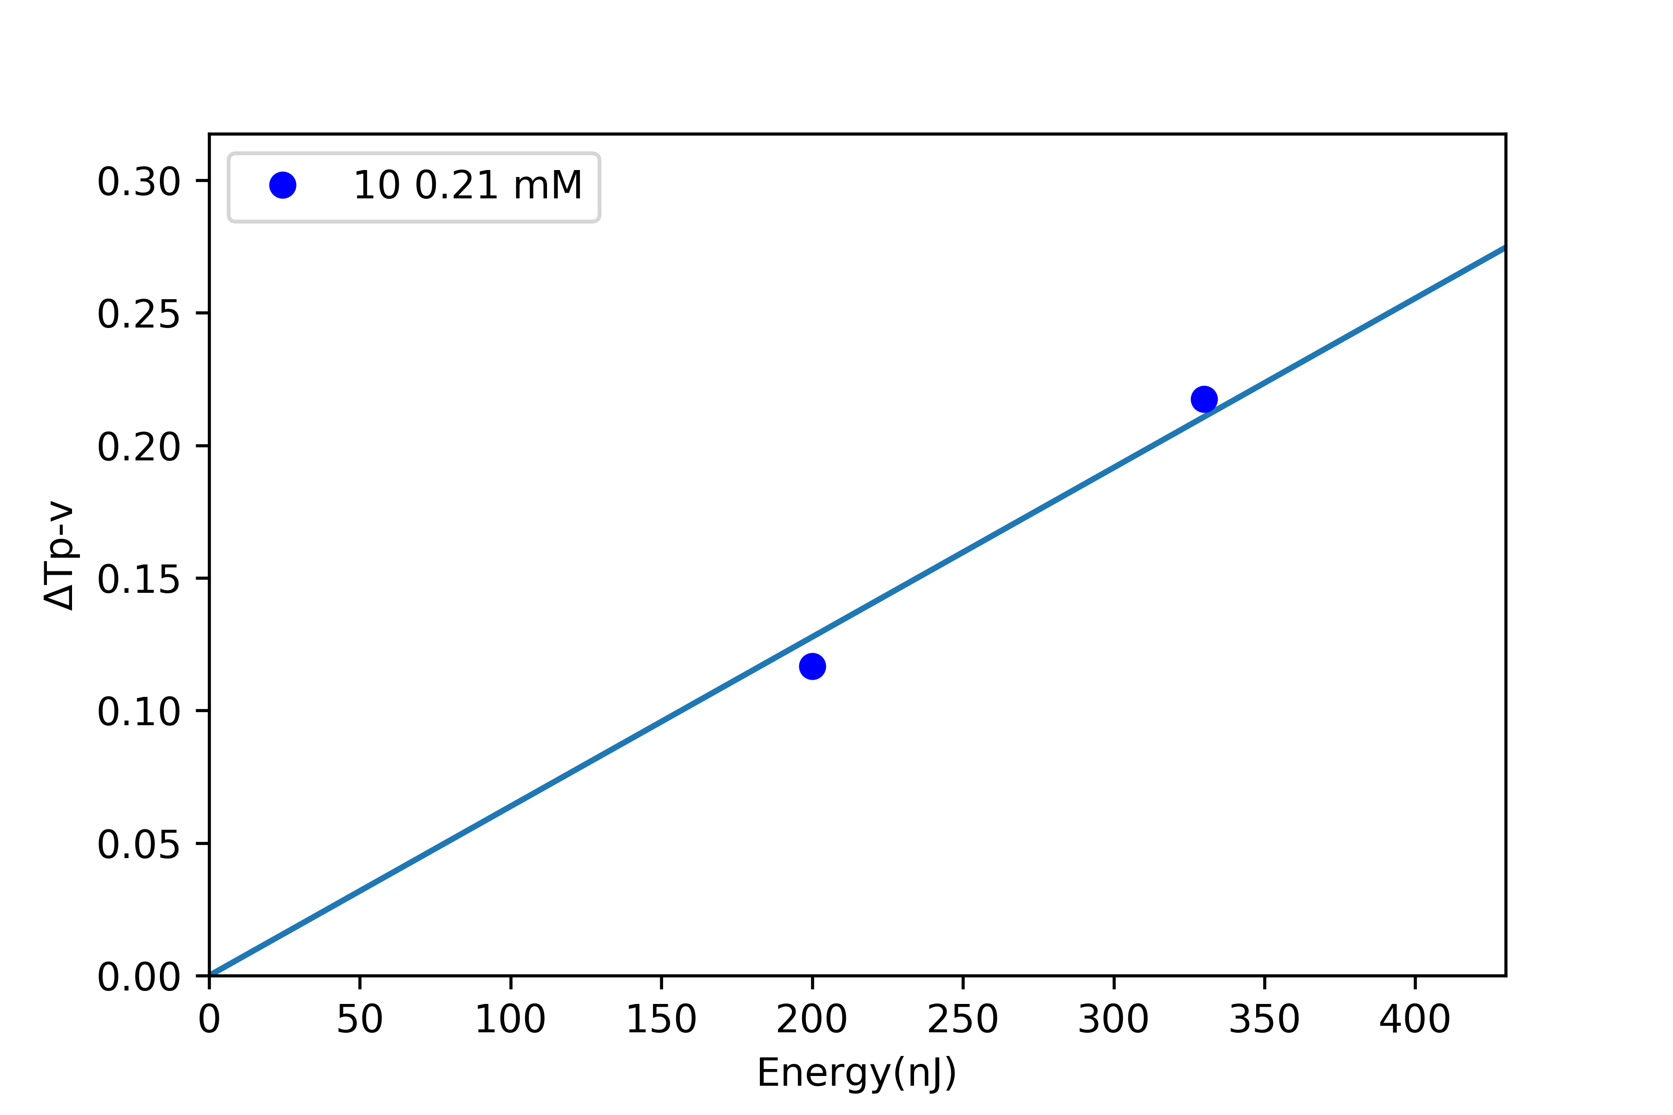

# 4 0.5 mM Z-scans

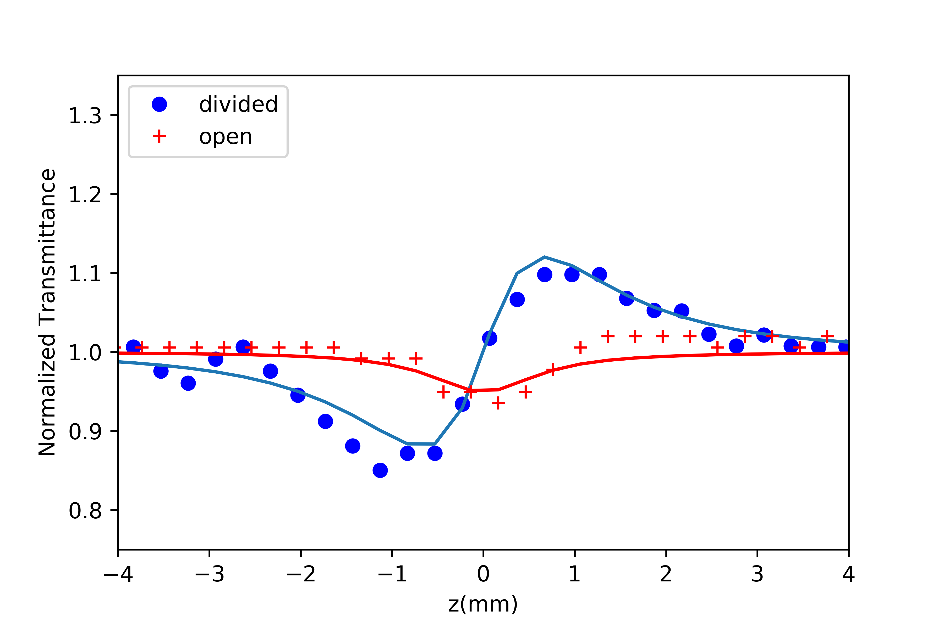

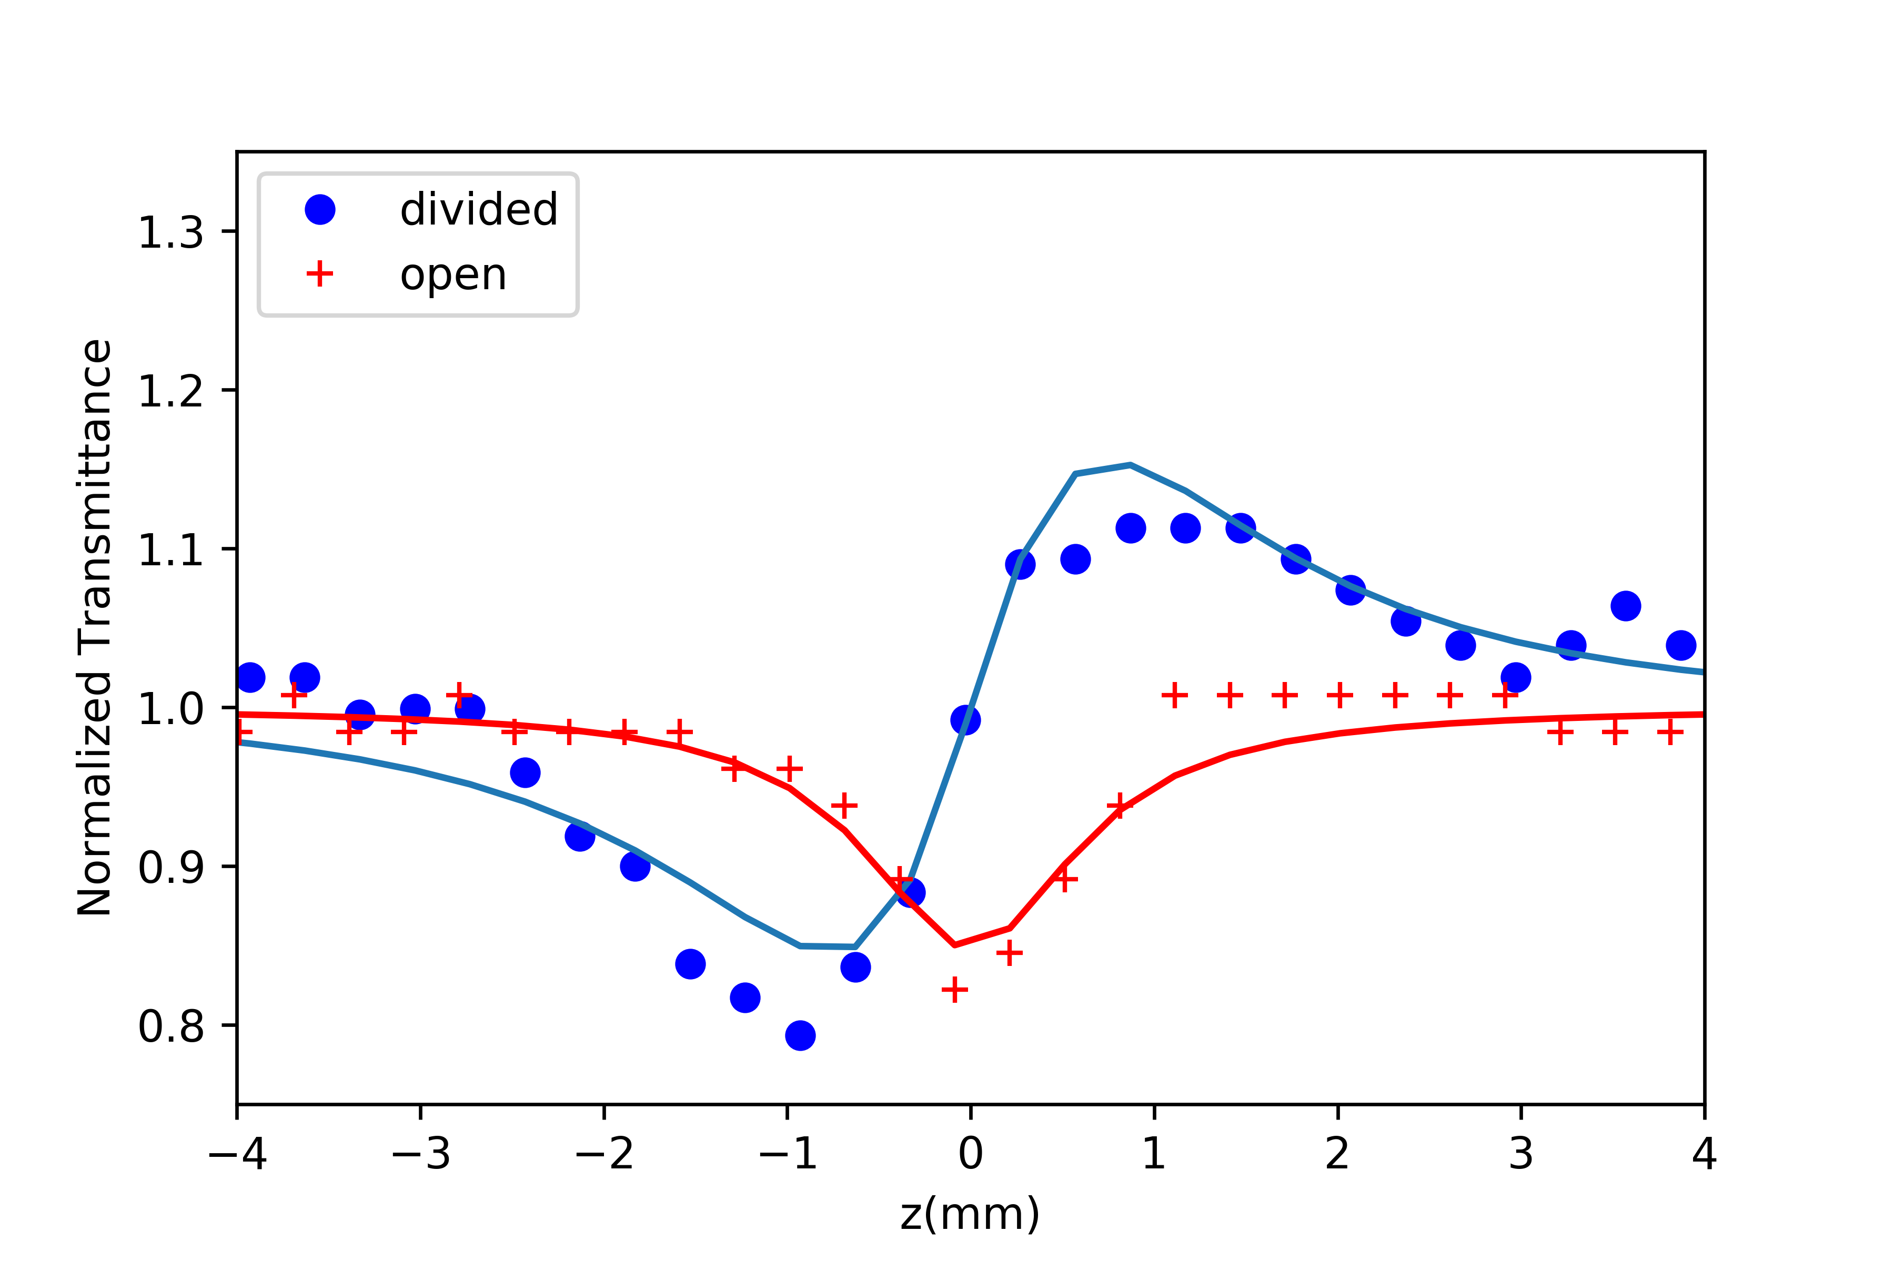

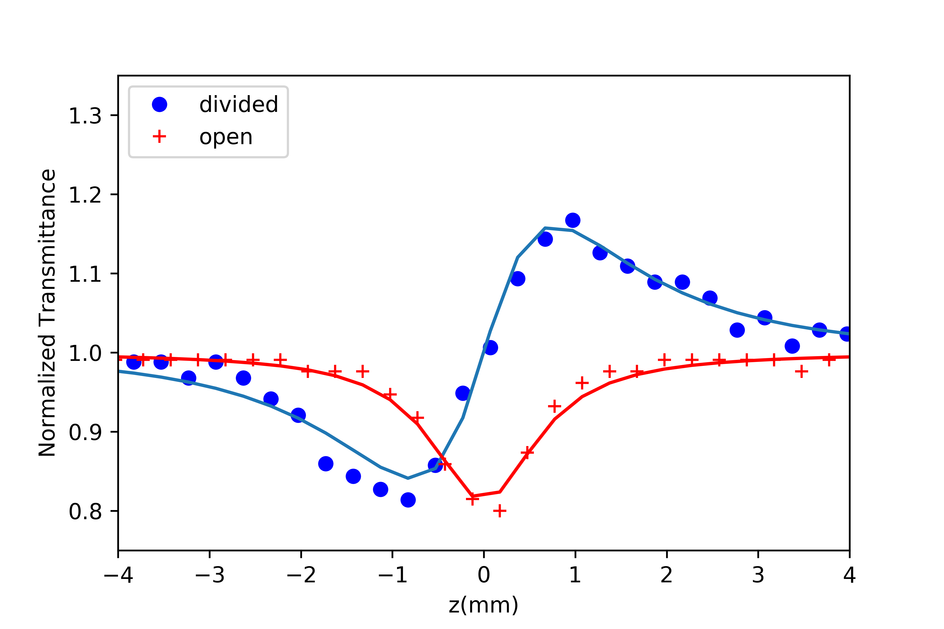

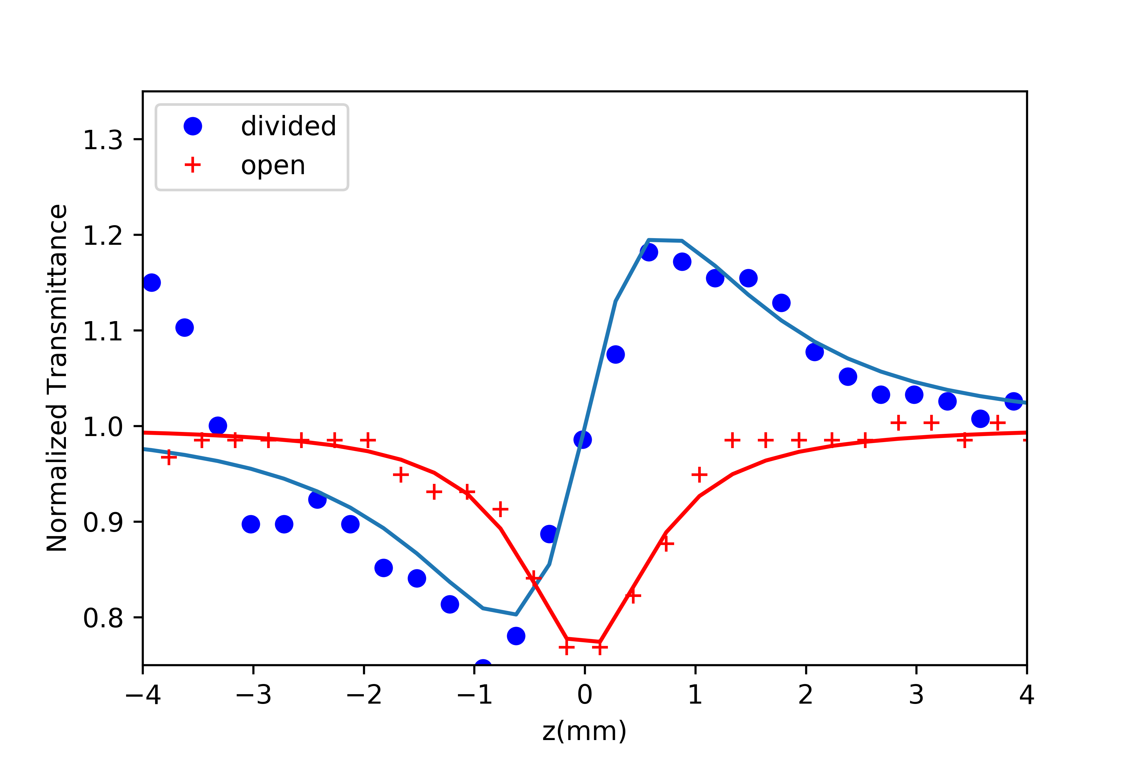

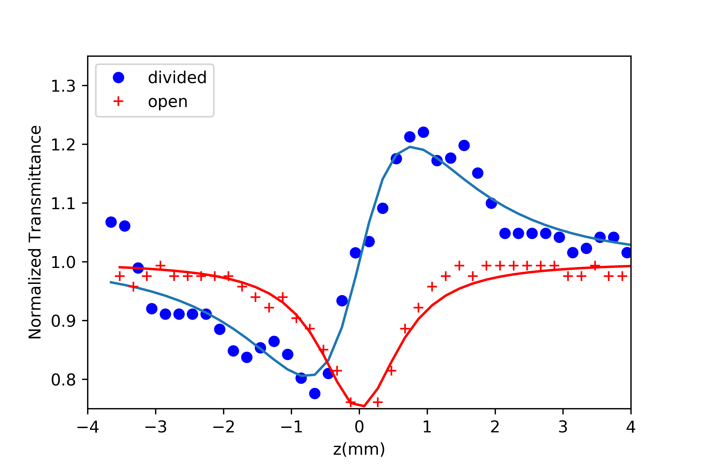

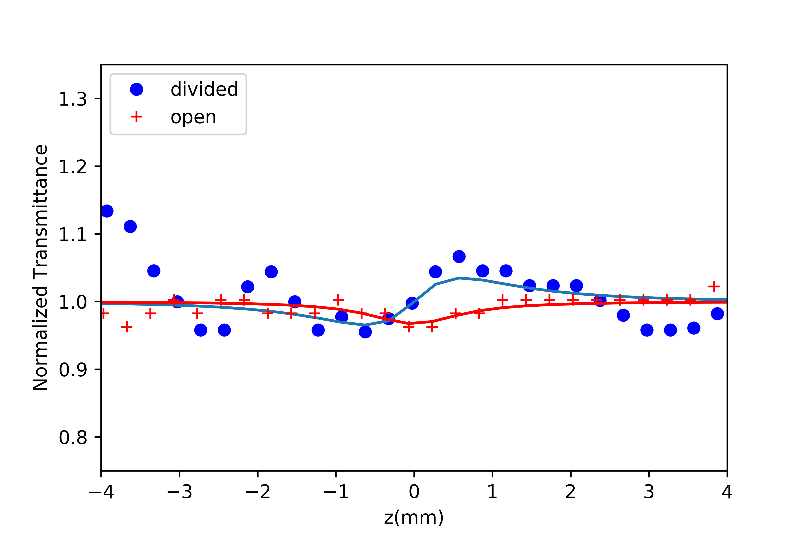

# 4 0.5 mM ΔΤp-v

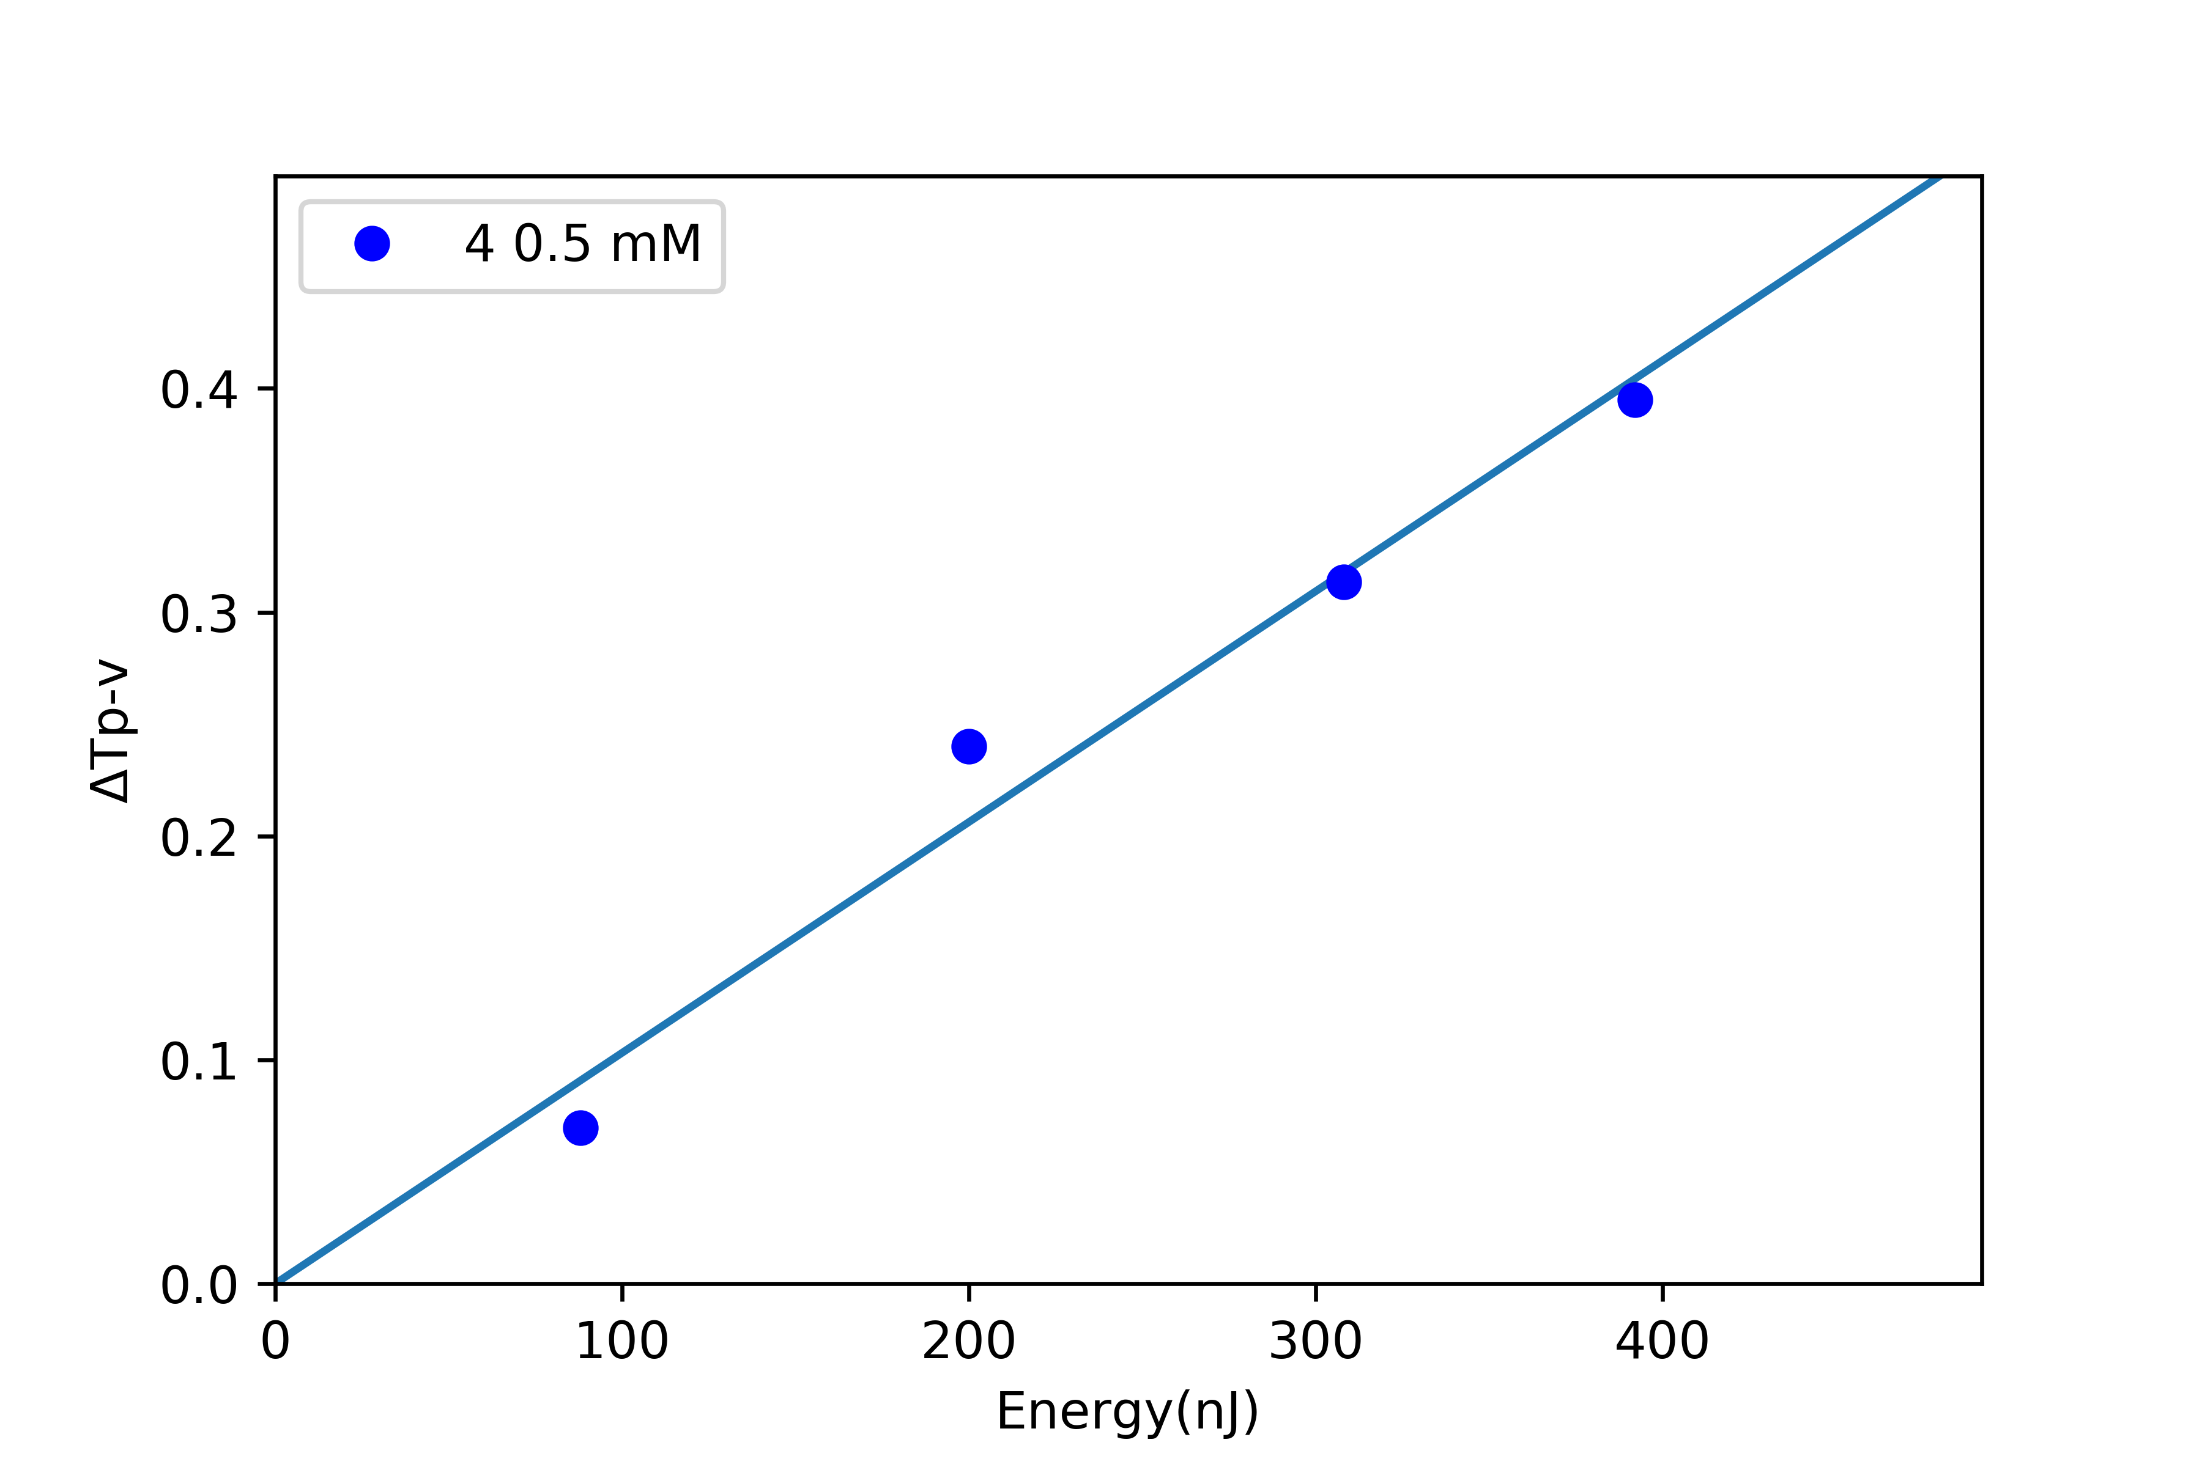

# Report 10032020

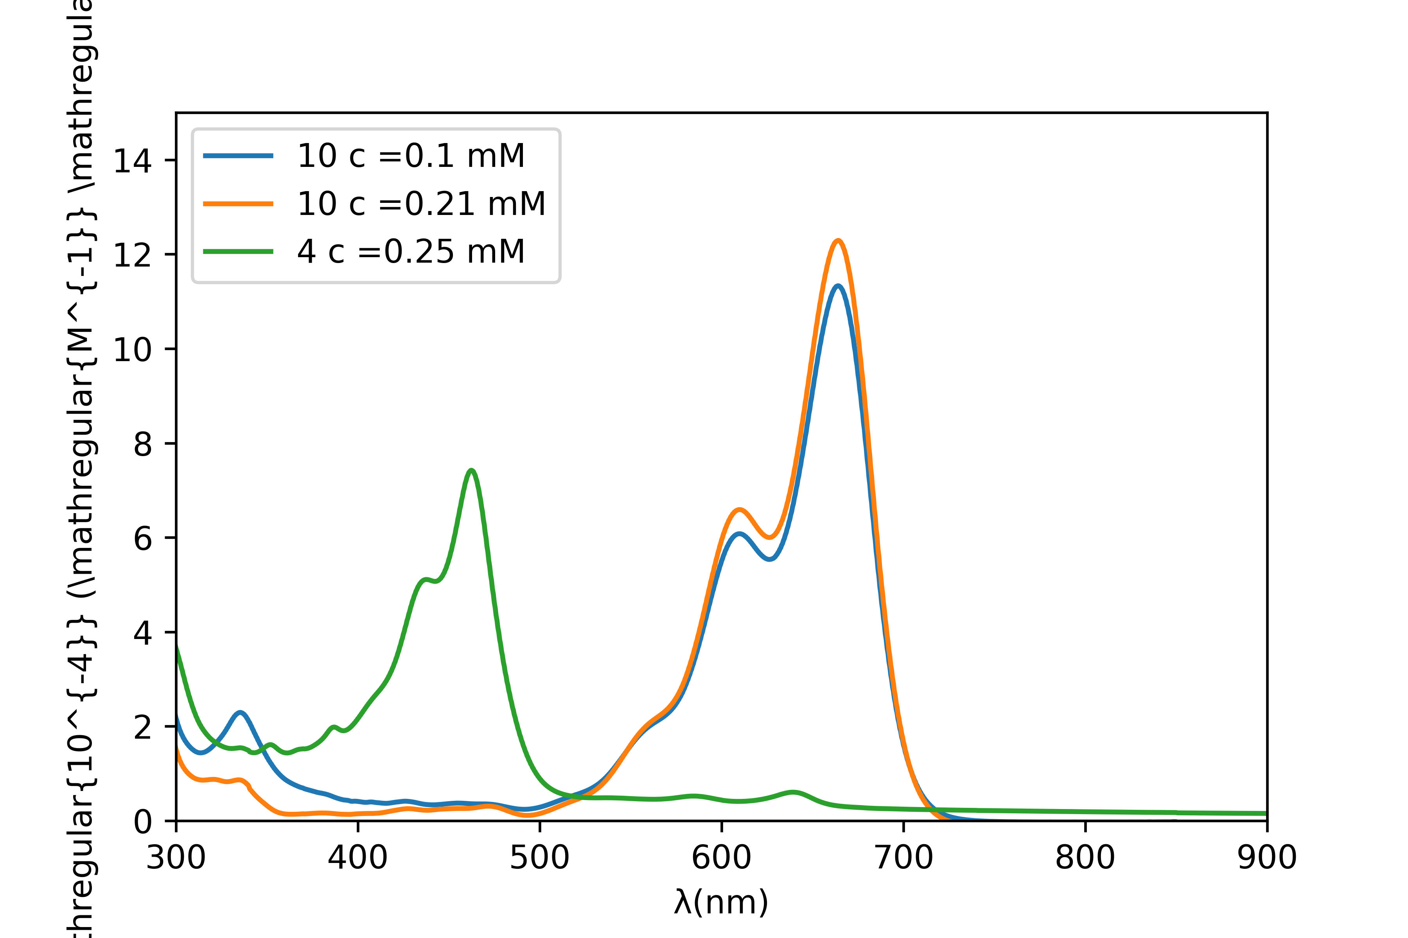

Fig. 1. UV vis spectrum of the molecules

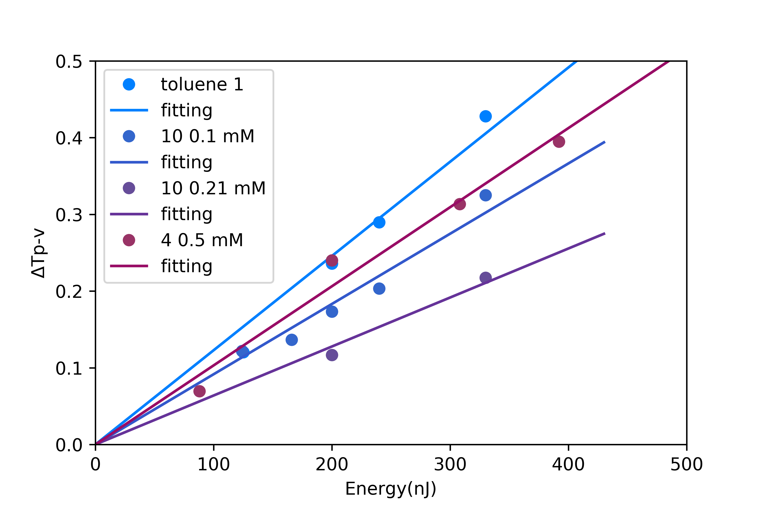

Fig. 2. ΔΤp-v values as a function of the incident laser energy

the nonlinear optics (NLO) properties of molecules {} and {}, {} and {} have ben systematically investigated using the Z-scan technique, employing 800 nm, 40fs pulses

Table 1. Nonlinear optical parameters (Z-scan: 40fs, 800 nm)

|  |  |  |  |  |  |  |  |  |
| --- | --- | --- | --- | --- | --- | --- | --- | --- |
|  | γ' (10-21m2/W) | Re(x(3)) (10-16 esu) | Reγ (10-33 esu) | β (&10^{-15}& m/W) | Imx(3) (10-16 esu) | x(3) (10-16 esu) | x(3)/c (10-16 esu/mM) |  |
| toluene 1 | 12.2 | 17.2 | 0.7332 | 6.70 | 0.59 | 17.3 | 17.3 |  |
| 10 0.1 mM | -3.1 | -4.4 | -1.866 | 15.3 | 1.36 | 4.60 | 46.0 |  |
| 10 0.21 mM | -5.9 | -8.3 | -1.676 | 26.0 | 2.31 | 8.62 | 41.0 |  |
| 4 0.5 mM | -1.9 | -2.7 | -0.235 | 13.4 | 1.19 | 3.02 | 6.05 |  |